（ 2017 至 2018 学年 第 2 学期 ）
年级专业： 教学班号： 学号： 姓名：

装 订 线

课程名称： Java EE 开发技术 考试时间： 110 分钟
课程代码： 150901089 试卷总分： 100 分
考试形式： 闭卷 学生自带普通计算器: 否

员工信息管理系统

- 语言和环境
  - 实现语言：Java
  - 环境要求：Eclipse ，MySQL

- 要求
请编写一个程序，完成对员工信息的管理 ，实现功能如下：
- 查看所有员工列表；
- 查看员工详细信息；
- 添加员工信息；
- 修改员工信息；
- 删除员工信息；
- 数据库设计

表名：TblDept （部门表）
序号 | 字段名称 | 字段说明 | 类型 | 位数 | 属性 | 备注
1 | deptid | 部门编号 | int |  | 标识列
2 | dname | 部门名称 | Varchar | 50 | 唯一
表名：TblEmp （员工表）
序号 | 字段名称 | 字段说明 | 类型 | 位数 | 属性 | 备注
1 | empid | 部门编号 | int |  | 标识列
2 | ename | 部门名称 | varchar | 50 | not null
3 | egendar | 性别 | tinyint |  | not null | 1男0女
4 | depid | 部门编号 | int |  | not null

- 推荐实现步骤
- 建立数据库，表结构见数据库设计；数据连接必须使用连接池技术。
- 建立名为HR的JAVA WEB项目
- 设计一个前台界面index.jsp，点击后显示员工列表。创建ListEmp Servlet，接收index.jsp请求，查询所有员工信息。转发到listemp.jsp员工列表。

程序编写目录结构：

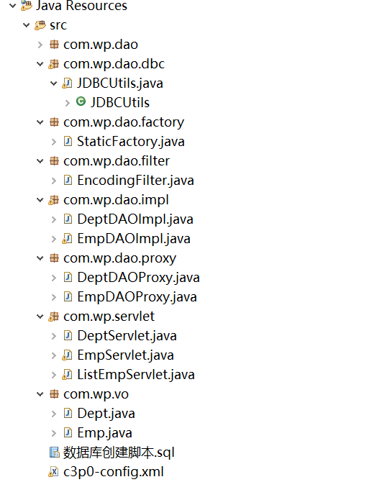

1.操作首页：
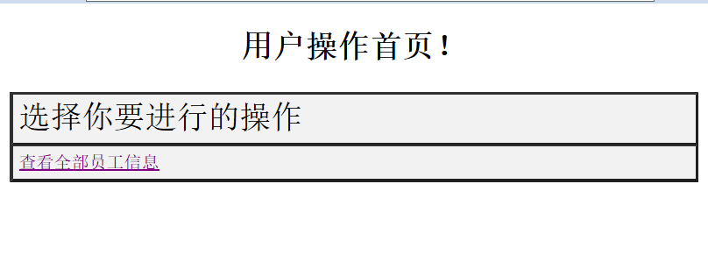

2.显示全部员工：
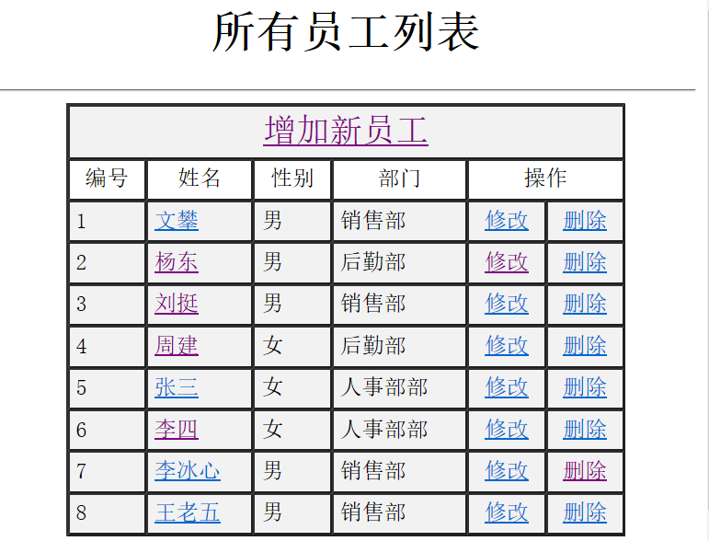

3.查看员工信息：
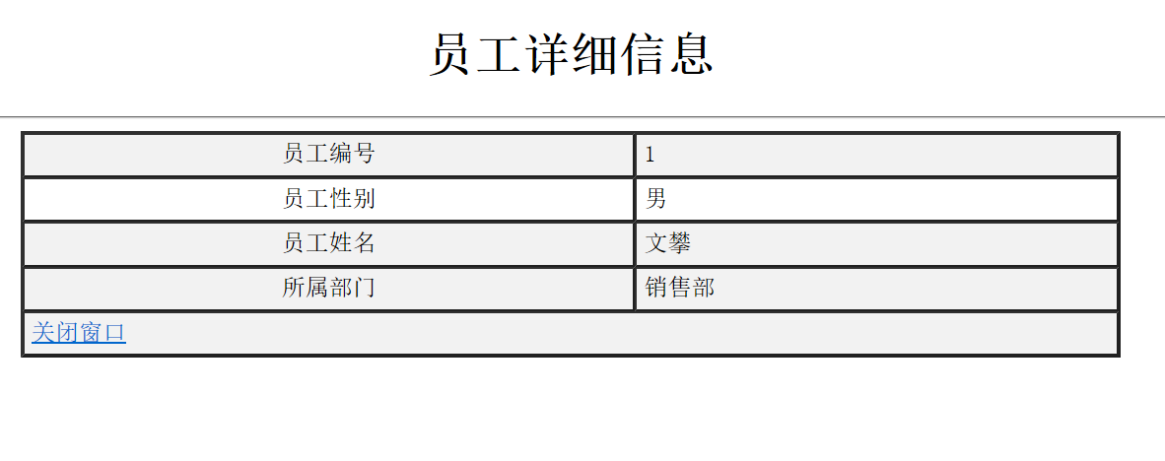

4.修改员工信息：
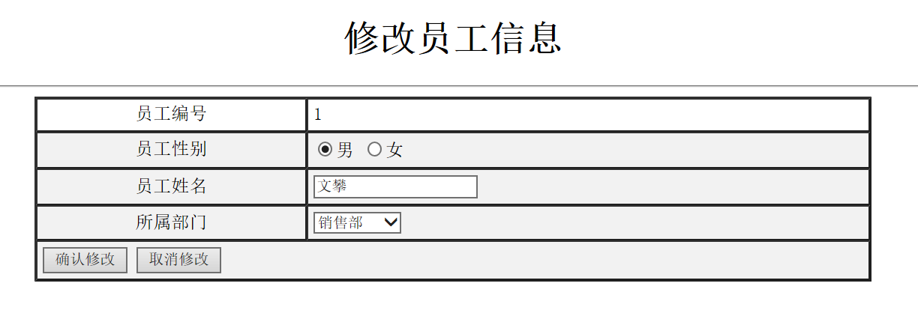
5.员工信息修改成功：
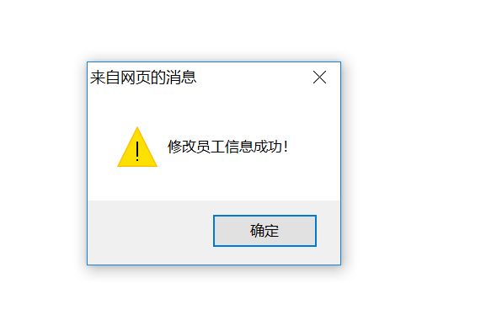

6.删除员工信息：
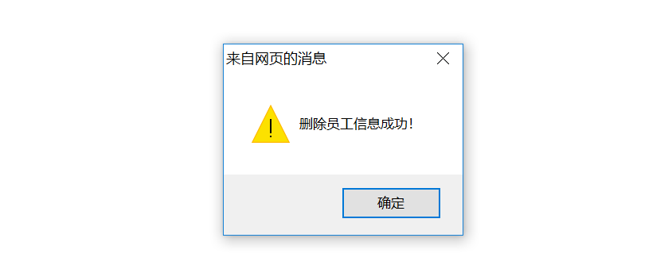

7.增加新员工：
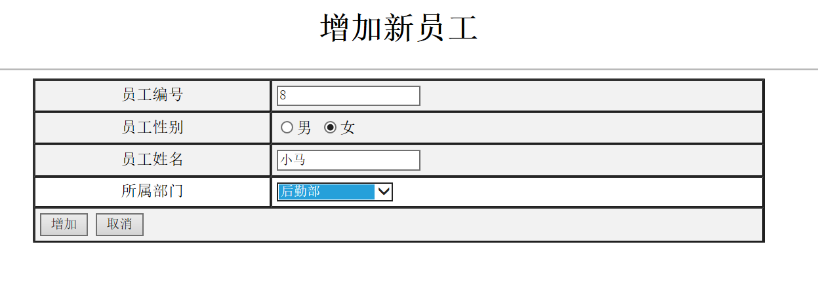
8.员工增加成功：
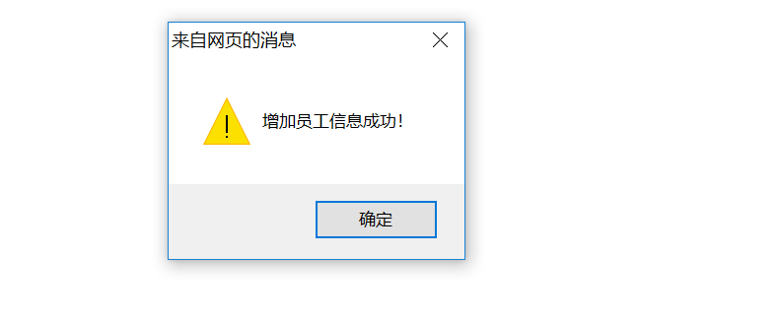

代码部分：

后台业务代码：

package com.wp.dao;
import java.util.List;

public interface IDAO<T,K> { //作为一个公用接口，使用泛型
public boolean doCreate(T vo) throws Exception;

public boolean doUpdate(T vo) throws Exception;

public boolean doRemove(K id) throws Exception;

public T findById(K id) throws Exception;

public List<T> findAll(String keyword) throws Exception;

public List<T> findAll(String keyword,int intcurrentPage,int lineSize)
throws Exception;

public long getAllCount(String keyword) throws Exception;
}

package com.wp.dao;
import com.wp.vo.Dept;
public interface IDeptDAO extends IDAO<Dept,Integer>{

}

package com.wp.dao;
import com.wp.vo.Emp;
public interface IEmpDAO extends IDAO<Emp,Integer>{

}

package com.wp.dao.dbc;

import java.sql.Connection;
import java.sql.SQLException;
import java.util.List;

import javax.sql.DataSource;

import org.apache.commons.dbutils.QueryRunner;
import org.apache.commons.dbutils.handlers.BeanListHandler;
import org.junit.Test;

import com.mchange.v2.c3p0.ComboPooledDataSource;
import com.wp.vo.Emp;

public class JDBCUtils {

public static DataSource dataSource = null;

static {
dataSource = new ComboPooledDataSource("helloC3P0"); //从配置文件中获取数据源
}

public static DataSource getDataSource() {
return dataSource; //返回数据源
}

public static Connection getConnection() { //返回数据库连接
Connection conn = null;
try {
conn = dataSource.getConnection();
} catch (SQLException e) {
e.printStackTrace();
}
return conn;
}

public static void close(Connection conn) { //关闭数据库连接
if(conn != null) {
try {
conn.close();
} catch (SQLException e) {
e.printStackTrace();
}
}
}
}

package com.wp.dao.filter;

import java.io.IOException;
import javax.servlet.Filter;
import javax.servlet.FilterChain;
import javax.servlet.FilterConfig;
import javax.servlet.ServletException;
import javax.servlet.ServletRequest;
import javax.servlet.ServletResponse;
import javax.servlet.annotation.WebFilter;

@WebFilter("/EncodingFilter")
public class EncodingFilter implements Filter {
String charSet;
public EncodingFilter() {
// TODO Auto-generated constructor stub
}

public void destroy() {
// TODO Auto-generated method stub
}

public void doFilter(ServletRequest request, ServletResponse response, FilterChain chain)
throws IOException, ServletException {
request.setCharacterEncoding(charSet);

chain.doFilter(request, response);
}

public void init(FilterConfig fConfig) throws ServletException {
charSet = fConfig.getInitParameter("charSet");
}

}

package com.wp.dao.impl;
import java.sql.Connection;
import java.util.List;

import org.apache.commons.dbutils.QueryRunner;
import org.apache.commons.dbutils.handlers.BeanHandler;
import org.apache.commons.dbutils.handlers.BeanListHandler;

import com.wp.dao.IDeptDAO;
import com.wp.dao.dbc.JDBCUtils;
import com.wp.vo.Dept;

public class DeptDAOImpl implements IDeptDAO{
Connection conn = null;
public DeptDAOImpl(Connection conn) {
this.conn = conn;
}

@Override
public boolean doCreate(Dept vo) throws Exception {
boolean flag = false;
QueryRunner runner = new QueryRunner();
String sql = "inset into TblDept(deptid,dname) values(?,?)";
Object params[] = {vo.getDeptid(),vo.getDname()};

if(runner.update(conn, sql, params) > 0) { //执行插入
flag = true;
}
return flag;
}

@Override
public boolean doUpdate(Dept vo) throws Exception {
boolean flag = false;
QueryRunner runner = new QueryRunner();
String sql = "update TblDept set dname=? where deptid=?";
Object params[] = {vo.getDname(),vo.getDeptid()}; //sql参数

if(runner.update(conn, sql, params) > 0) { //支持事务回滚
flag = true;
}
return flag;
}

@Override
public boolean doRemove(Integer id) throws Exception {
boolean flag = false;
QueryRunner runner = new QueryRunner();
String sql = "delete Tbl where deptid=?";

if(runner.update(conn, sql, id) > 0) { //支持事务回滚
flag = true;
}
return flag;
}

@Override
public Dept findById(Integer id) throws Exception {
Dept dept = null;
QueryRunner runner = new QueryRunner(JDBCUtils.getDataSource());
String sql = "select deptid,dname from TblDept where deptid = ?";
dept = runner.query(sql, new BeanHandler<Dept>(Dept.class), id); //将查询到的一行内容封装为一个bean
return dept;
}

@Override
public List<Dept> findAll(String keyword) throws Exception {
List<Dept> alldept = null;
QueryRunner runner = new QueryRunner(JDBCUtils.getDataSource());
String sql = "select deptid,dname from TblDept";
alldept = runner.query(sql, new BeanListHandler<Dept>(Dept.class));
return alldept;
}

@Override
public List<Dept> findAll(String keyword, int intcurrentPage, int lineSize) throws Exception {
throw new Exception("此方法未实现");
}

@Override
public long getAllCount(String keyword) throws Exception {
throw new Exception("此方法未实现");
}

}

package com.wp.dao.impl;
import java.sql.Connection;
import java.sql.PreparedStatement;
import java.sql.SQLException;
import java.util.List;

import org.apache.commons.dbutils.QueryRunner;
import org.apache.commons.dbutils.handlers.BeanHandler;
import org.apache.commons.dbutils.handlers.BeanListHandler;
import org.junit.Test;

import com.sun.corba.se.impl.orb.ParserTable.TestAcceptor1;
import com.sun.java_cup.internal.runtime.virtual_parse_stack;
import com.sun.org.apache.bcel.internal.generic.NEW;
import com.wp.dao.IEmpDAO;
import com.wp.dao.dbc.JDBCUtils;
import com.wp.vo.Emp;

import oracle.net.aso.e;

public class EmpDAOImpl implements IEmpDAO { //对员工的实际操作类
Connection conn = null;
PreparedStatement pstmt = null;
public EmpDAOImpl(Connection conn) {
this.conn = conn;
}

@Override
public boolean doCreate(Emp vo) throws Exception {
boolean flag = false;
QueryRunner runner = new QueryRunner(); //带有事务回滚
String sql = "insert into TblEmp(empid,ename,egendar,deptid) values(?,?,?,?)";
Object params[] = {vo.getEmpid(),vo.getEname(),vo.getEgendar(),vo.getDeptid()}; //设置sql语句的参数

if(runner.update(conn, sql, params) > 0) { //执行插入操作
flag = true;
}
return flag;
}

@Override
public boolean doUpdate(Emp vo) throws Exception {
boolean flag = false;
QueryRunner runner = new QueryRunner();
String sql = "update TblEmp set ename = ?,egendar = ?,deptid = ? where empid = ?";
Object params[] = {vo.getEname(),vo.getEgendar(),vo.getDeptid(),vo.getEmpid()};

if(runner.update(conn, sql, params) > 0) { //执行更新
flag = true;
}
return flag;
}

@Override
public boolean doRemove(Integer id) throws Exception {
boolean flag = false;
QueryRunner runner = new QueryRunner();
String sql = "delete TblEmp where empid = ?";
if(runner.update(conn, sql,id) > 0) { //执行删除成功
flag = true;
}

return flag;
}

@Override
public Emp findById(Integer id) throws Exception {
Emp emp = null;
QueryRunner runner = new QueryRunner(JDBCUtils.getDataSource()); //不进行事务处理
String sql = "select empid,ename,egendar,deptid from TblEmp where empid=?";
emp = runner.query(sql, new BeanHandler<>(Emp.class), id); //设置查询内容，查询语句，参数
return emp;
}

@Override
public List<Emp> findAll(String keyword) throws Exception { //查找全部
//BeanListHandler：将结果集中的每一行数据都封装到一个对应的JavaBean实例中，存放到List里。
QueryRunner runner = new QueryRunner(JDBCUtils.getDataSource()); //创建一个queryRuner
String sql = "select empid,ename,egendar,deptid from TblEmp order by empid";
List<Emp> list = runner.query(sql, new BeanListHandler<>(Emp.class)); //执行查询操作，并且将查询结果保存到list集合
return list;
}

@Override
public List<Emp> findAll(String keyword, int intcurrentPage, int lineSize) throws Exception {
throw new Exception("此方法未实现");
}

@Override
public long getAllCount(String keyword) throws Exception {
// TODO Auto-generated method stub
return 0;
}

}

package com.wp.servlet;

import java.io.IOException;
import java.lang.reflect.InvocationTargetException;
import java.util.ArrayList;
import java.util.List;

import javax.servlet.ServletException;
import javax.servlet.annotation.WebServlet;
import javax.servlet.http.HttpServlet;
import javax.servlet.http.HttpServletRequest;
import javax.servlet.http.HttpServletResponse;

import org.apache.commons.beanutils.BeanUtils;

import com.wp.dao.factory.StaticFactory;
import com.wp.vo.Dept;
import com.wp.vo.Emp;

@WebServlet("/EmpServlet")
public class EmpServlet extends HttpServlet {
private static final long serialVersionUID = 1L;

protected void doGet(HttpServletRequest request, HttpServletResponse response) throws ServletException, IOException {

String status = request.getParameter("status");
if("updatepre".equals(status)) {
updatepre(request,response);
}
if("update".equals(status)) {
update(request,response);
}
if("delete".equals(status)) {
try {
delete(request,response);
} catch (Exception e) {
e.printStackTrace();
}
}
if("show".equals(status)) {
try {
show(request,response);
} catch (Exception e) {
e.printStackTrace();
}
}
if("add".equals(status)) {
try {
add(request,response);
} catch (Exception e) {
e.printStackTrace();
}
}
if("addpre".equals(status)) {
try {
addpre(request,response);
} catch (Exception e) {
e.printStackTrace();
}
}

response.getWriter().append("Served at: ").append(request.getContextPath());
}

protected void doPost(HttpServletRequest request, HttpServletResponse response) throws ServletException, IOException {
doGet(request, response);
}

public void updatepre(HttpServletRequest request, HttpServletResponse response) throws ServletException, IOException {
String pages = "error.jsp";
int empid = Integer.parseInt(request.getParameter("empid"));
Emp emp = null;
List<Dept> depts = null;
try {
emp = StaticFactory.getEmpInstance().findById(empid); //通过id查询到要修改的员工信息
depts = StaticFactory.getDeptInstance().findAll(""); //取得全部的部门信息
} catch (Exception e) {
e.printStackTrace();
}

request.setAttribute("emp", emp);
request.setAttribute("depts", depts);
pages = "update.jsp";
request.getRequestDispatcher(pages).forward(request, response); //执行页面跳转
}
public void update(HttpServletRequest request, HttpServletResponse response) throws ServletException, IOException {
String pages = "error.jsp";
String msg = "修改员工信息失败！";
boolean flag = false;
Emp emp = new Emp();
try {
BeanUtils.populate(emp, request.getParameterMap()); //自动将提交过来的信息封装为一个emp对象,不在一个一个的接收了
flag = StaticFactory.getEmpInstance().doUpdate(emp);
} catch (Exception e) {
e.printStackTrace();
}
if(flag) {
msg = "修改员工信息成功！";
}

request.setAttribute("msg", msg);
pages = "delete_do.jsp";
request.getRequestDispatcher(pages).forward(request, response);
}

public void delete(HttpServletRequest request, HttpServletResponse response) throws Exception {
String pages = "error.jsp";
String msg = "删除员工信息失败！";
int empid = Integer.parseInt(request.getParameter("empid"));
boolean flag = false;
flag = StaticFactory.getEmpInstance().doRemove(empid);
if(flag) {
msg = "删除员工信息成功！";
}
request.setAttribute("msg", msg);
pages = "delete_do.jsp";
request.getRequestDispatcher(pages).forward(request, response);

}
public void show(HttpServletRequest request, HttpServletResponse response) throws Exception {
String pages = "error.jsp";
Emp emp = null;
Dept dept = null;
int id = Integer.parseInt(request.getParameter("empid"));
try {
dept = StaticFactory.getDeptInstance().findById(Integer.parseInt(request.getParameter("deptid"))); //按id值查找部门信息
emp = StaticFactory.getEmpInstance().findById(id);
pages = "show.jsp";
} catch (Exception e) {
e.printStackTrace();
}

request.setAttribute("emp", emp); //保存查询出来的员工
request.setAttribute("dept", dept); //保存部门信息
request.getRequestDispatcher(pages).forward(request, response); //执行页面跳转

}
public void add(HttpServletRequest request, HttpServletResponse response) throws ServletException, IOException {
String pages = "error.jsp";
String msg = "已存在该员工编号，增加员工失败！";
Emp emp = new Emp();
try {
BeanUtils.populate(emp, request.getParameterMap()); //自动将提交过来的信息封装为一个emp对象,不在一个一个的接收了

if(StaticFactory.getEmpInstance().doCreate(emp)) {
msg = "增加员工信息成功！";
}

} catch (Exception e) {
e.printStackTrace();
}

request.setAttribute("msg", msg);
pages = "add_do.jsp";
request.getRequestDispatcher(pages).forward(request, response);
}
public void addpre(HttpServletRequest request, HttpServletResponse response) throws ServletException, IOException {
String pages = "error.jsp";
List<Dept> depts = null;

try {
depts = StaticFactory.getDeptInstance().findAll(""); //查找到所有的部门信息
} catch (Exception e) {
e.printStackTrace();
}
request.setAttribute("depts", depts);
pages = "add.jsp";
request.getRequestDispatcher(pages).forward(request, response);
}

}

package com.wp.servlet;

import java.io.IOException;
import java.util.ArrayList;
import java.util.List;

import javax.servlet.ServletException;
import javax.servlet.annotation.WebServlet;
import javax.servlet.http.HttpServlet;
import javax.servlet.http.HttpServletRequest;
import javax.servlet.http.HttpServletResponse;

import com.wp.dao.factory.StaticFactory;
import com.wp.vo.Dept;
import com.wp.vo.Emp;

@WebServlet("/ListEmpServlet")
public class ListEmpServlet extends HttpServlet {
private static final long serialVersionUID = 1L;

protected void doGet(HttpServletRequest request, HttpServletResponse response) throws ServletException, IOException {
//查询出所有的员工信息然后保存在属性范围
String pages = "error.jsp";
List<Emp> all = null;
List<Dept> depts = null;
try {
all = StaticFactory.getEmpInstance().findAll(""); //取得所有的员工信息
depts = StaticFactory.getDeptInstance().findAll(""); //取得所有的部门信息
pages = "listemp.jsp";
} catch (Exception e) {
e.printStackTrace();
}

request.setAttribute("all", all);
request.setAttribute("depts", depts);
request.getRequestDispatcher(pages).forward(request, response); //执行跳转
response.getWriter().append("Served at: ").append(request.getContextPath());
}

protected void doPost(HttpServletRequest request, HttpServletResponse response) throws ServletException, IOException {
doGet(request, response);
}
}

- 注意事项
- 仔细审题，把题目要求理解准确；
- 请注意按照界面的设计要求来进行窗体设计；
- 请注意代码的书写、命名规范和适当的注释。

